What is a Computer?

- A computer is a device that processes data and can used to be perform a wide range of tasks, from basic calculations to complex operations involving AI.

It has two main parts which are the hardware and the software. The hardware is responsible for executing tasks and it refers to the computer's physical components, and the software provides the hardware with directions for what task is performed.

Most computers rely on a binary system, which uses two variables, 0 and 1, to complete tasks such as storing data, calculating algorithms, and displaying information.

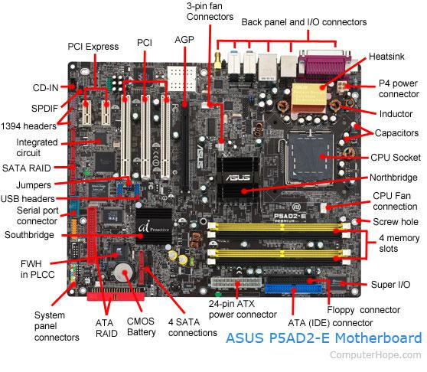

What are the essential parts of the computer? -

The Motherboard - This is the main circuit board of a computer and its foundation that connects and enables communication between all components.

Central Processing Unit (CPU) - It is often called as the brain of a computer, its the electronic circuitry that executes instructions of a computer program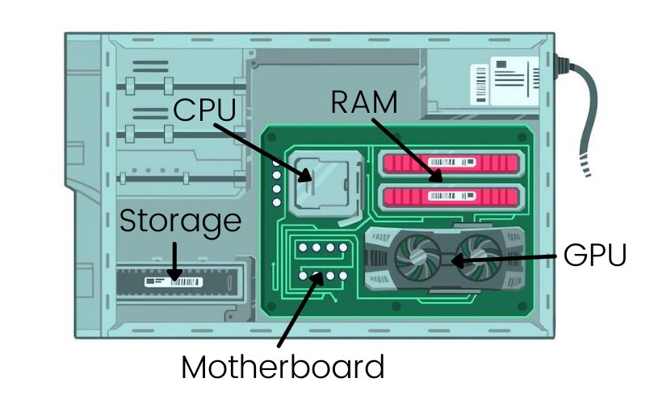

RAM - It is essentially your computer’s short-term memory. It can hold data that the CPU needs to access immediately. Data can be read from and written to RAM much faster than the storage devices.

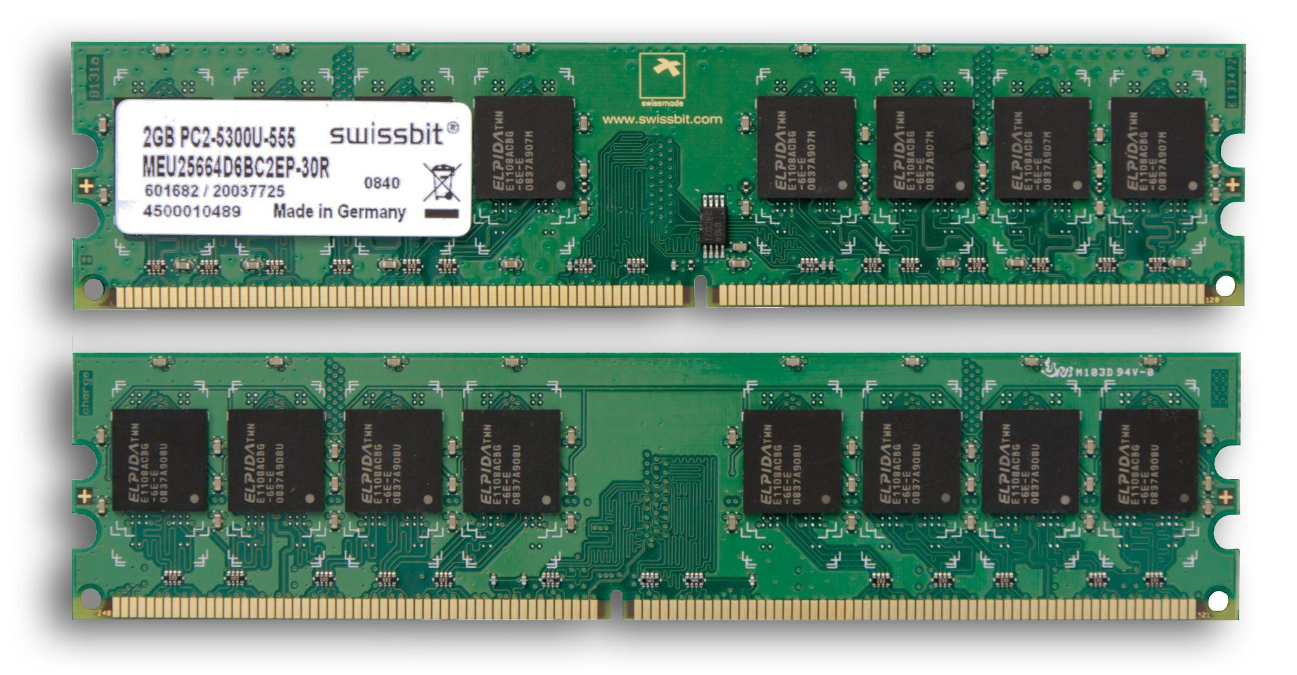

Hard drive - It is where your computer stores all of your files. It holds your operating system, applications, documents, photos, etc. It uses a magnetic disk to store data, the heads move across the disks to read and write data.

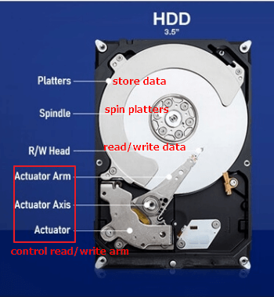

Power supply - It is the component responsible for converting the alternating current AC power from the wall outlet across the direct current.

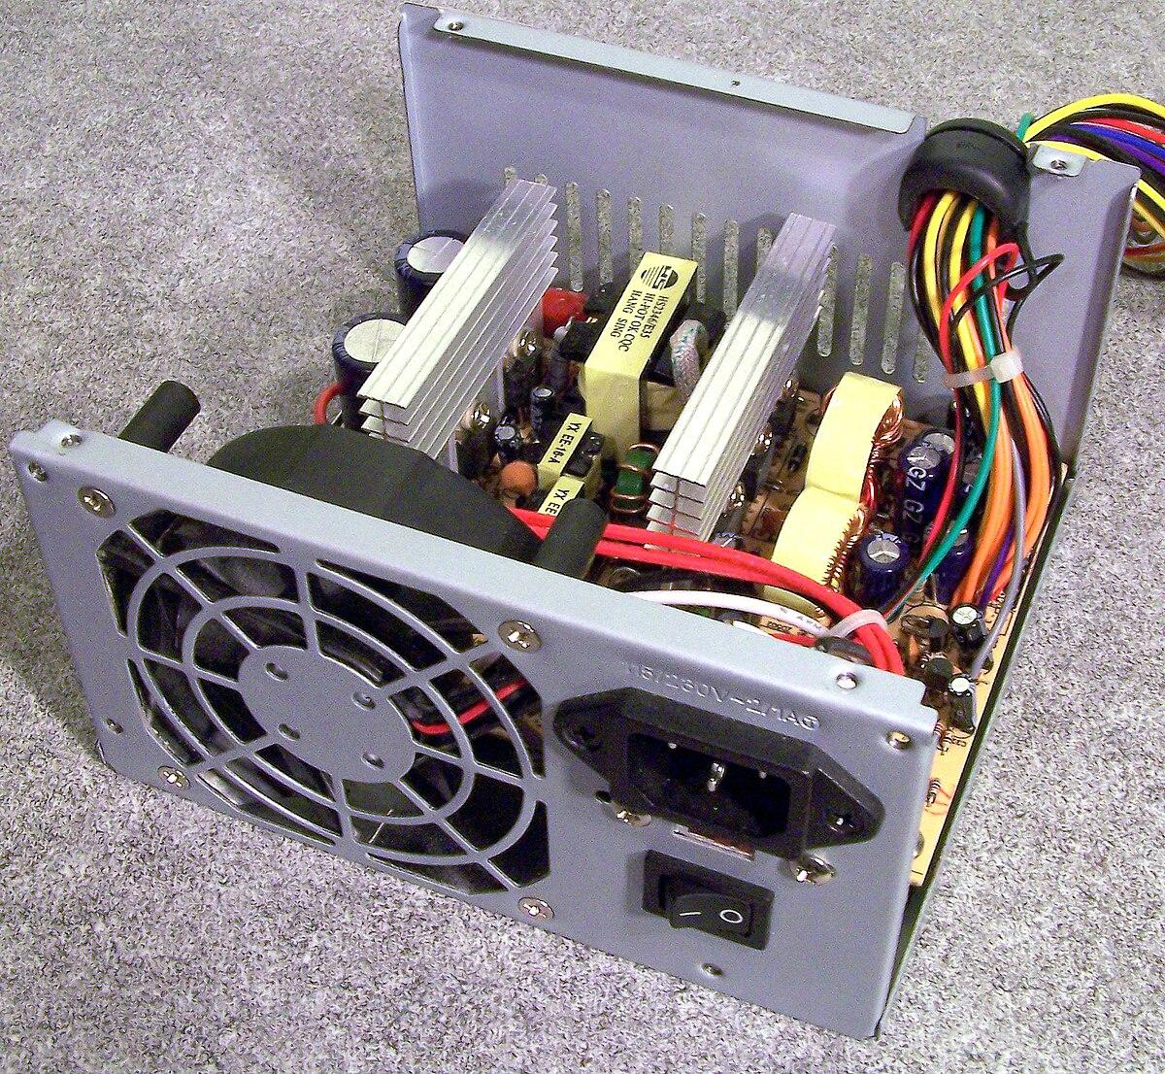

GPU - It is specialized as a electronic circuit designed to rapidly manipulate and alter memory to accelerate the creation of images.

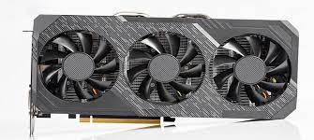

Who are the notable inventors of hardware and software? Cite at least (5) software developers and (5) hardware developers.

SOFTWARE INVESTORS:

1, Marc Andreessen – Netscape, the first widely-used web browser, and the co-founder of Netscape Communications.

2, Larry Page and Sergey Brin – Google, they invented Google in 1996 as a research project and then the Google website launched in 1997, and by the end of 1998 it had indexed about 60 million web pages.

3, Steve Jobs – Apple, Pixar, the co-founder of apple and a co-founder/former CEO of Pixar Animation Studios

4, Tim Berners-Lee – World Wide Web, the inventor of the World Wide Web in March 1989. Published the first website on August 6, 1991. Tim Berners-Lee founded World Wide Web Consortium (W3C) at the Massachusetts Institute of Technology

5, Bill Gates – Microsoft, is the co-founder and chairman of Microsoft which is the world's largest software company with over 79,000 employees in 102 countries and a $51 billion in annual sales

HARDWARE INVENTORS:

1, Federico Faggin invented the first commercial CPU. He is a physicist, inventor, and entrepreneur. Born and raised, and educated in Italy. He was credited by designing the worlds first commercial microprocessor, the Intel 4004

2, Patty McHugh invented the motherboard. The first backplane to qualify as a motherboard was a Planar Breadboard.

3, Robert Dennard invented the Dynamic Random Access Memory (RAM). In the 1967, Robert Heath Dennard invented what is considered to be one of the most significant advances in computer technology which he called the one-transistor dynamics random access memory, or DRAM

4, Reynold B. Johnson came up with the idea of the external hard drive. An American inventor and computer pioneer, Johnson is said to be the "father" of the hard drive disk.

5, Fujio Masuoka invented the basis for flash-based SSDs, flash memory

Cite your reference/s

Margaret Rouse (2024) What is a Computer? Everything You Need To Know.

<https://www.techopedia.com/definition/4607/computer>

Computer basics: Inside a computer. (n.d.).

GCFGlobal.org. <https://edu.gcfglobal.org/en/computerbasics/inside-a-computer/1/>

Top 10 software innovators of all time. (n.d.).

<https://www.devtopics.com/top-10-software-innovators-of-all-time/>

Computer basics: Buttons and ports on a computer. (n.d.).

GCFGlobal.org.

<https://edu.gcfglobal.org/en/computerbasics/buttons-and-ports-on-a-computer/1/>

Computer History Museum. (2021, February 12). Federico Faggin -

CHM. CHM. <https://computerhistory.org/profile/federico-faggin/>

Arm Ltd. (no date) *What is a Central Processing Unit? – Arm®*. <https://www.arm.com/glossary/cpu#:~:text=What%20is%20a%20Central%20Processing%20Unit%20(CPU)%3F,as%20its%20%E2%80%9Ccontrol%20center.%E2%80%9D&text=The%20CPU%20interprets%2C%20processes%20and,programs%20running%20on%20the%20device>.

Villinger, S. (2024b) *What is RAM and why does random access memory matter?* <https://www.avast.com/c-what-is-ram-memory#:~:text=RAM%20keeps%20data%20easily%20accessible,to%20complete%20immediate%20processing%20tasks>.

Seagate (no date) *Everything You Want to Know About Hard Drives.* ***Understanding hard drive basics will help you make better storage decisions.****| Seagate UK*. <https://www.seagate.com/as/en/blog/everything-you-wanted-to-know-about-hard-drives-master-dm/#:~:text=or%20External%20Drive%3F-,What%20Does%20a%20Hard%20Drive%20Do%3F,all%20of%20your%20digital%20content.&text=Your%20documents%2C%20pictures%2C%20music%2C,stored%20on%20a%20hard%20drive>.

*POWER SUPPLY BASICS – Wavelength Electronics* (no date).

<https://www.teamwavelength.com/power-supply-basics/#:~:text=Power%20is%20the%20backbone%20of,%2C%20switched%20and%20battery%2Dbased>.

*What is a GPU? - Graphics Processing Unit Explained - AWS* (no date). <https://aws.amazon.com/what-is/gpu/#:~:text=The%20GPU%20integrated%20a%20previously,all%20on%20a%20programmable%20chip>.